BioMechanical.R

19BME134 (Shrey Shah)

20BME503 (Alpesh Gohel)

library(ClusterR)

library(cluster)  
library(neuralnet)  
library(party)

library(rpart)  
library(rpart.plot)  
library(randomForest)

library(ggplot2)

library(e1071)

library(MASS)  
library(caTools)  
library(class)  
  
setwd("E:/R/assignment/biomedical")  
  
minmax <- function(x)  
{  
 (x - min(x))/(max(x) - min(x))  
}  
  
# 1) Using logistic regression to find abnormal and normal cases  
  
data <- read.csv("column_2C_weka.csv")  
head(data)

## pelvic_incidence pelvic_tilt.numeric lumbar_lordosis_angle sacral_slope  
## 1 63.02782 22.552586 39.60912 40.47523  
## 2 39.05695 10.060991 25.01538 28.99596  
## 3 68.83202 22.218482 50.09219 46.61354  
## 4 69.29701 24.652878 44.31124 44.64413  
## 5 49.71286 9.652075 28.31741 40.06078  
## 6 40.25020 13.921907 25.12495 26.32829  
## pelvic_radius degree_spondylolisthesis class  
## 1 98.67292 -0.254400 Abnormal  
## 2 114.40543 4.564259 Abnormal  
## 3 105.98514 -3.530317 Abnormal  
## 4 101.86850 11.211523 Abnormal  
## 5 108.16872 7.918501 Abnormal  
## 6 130.32787 2.230652 Abnormal

summary(data)

## pelvic_incidence pelvic_tilt.numeric lumbar_lordosis_angle sacral_slope   
## Min. : 26.15 Min. :-6.555 Min. : 14.00 Min. : 13.37   
## 1st Qu.: 46.43 1st Qu.:10.667 1st Qu.: 37.00 1st Qu.: 33.35   
## Median : 58.69 Median :16.358 Median : 49.56 Median : 42.40   
## Mean : 60.50 Mean :17.543 Mean : 51.93 Mean : 42.95   
## 3rd Qu.: 72.88 3rd Qu.:22.120 3rd Qu.: 63.00 3rd Qu.: 52.70   
## Max. :129.83 Max. :49.432 Max. :125.74 Max. :121.43   
## pelvic_radius degree_spondylolisthesis class   
## Min. : 70.08 Min. :-11.058 Length:310   
## 1st Qu.:110.71 1st Qu.: 1.604 Class :character   
## Median :118.27 Median : 11.768 Mode :character   
## Mean :117.92 Mean : 26.297   
## 3rd Qu.:125.47 3rd Qu.: 41.287   
## Max. :163.07 Max. :418.543

response = data[,7]  
features <- data[-7]  
response_number = as.factor(response)  
response_number_1 = ifelse(response == "Abnormal",1,0)  
response_number_1

## [1] 1 1 1 1 1 1 1 1 1 1 1 1 1 1 1 1 1 1 1 1 1 1 1 1 1 1 1 1 1 1 1 1 1 1 1 1 1  
## [38] 1 1 1 1 1 1 1 1 1 1 1 1 1 1 1 1 1 1 1 1 1 1 1 1 1 1 1 1 1 1 1 1 1 1 1 1 1  
## [75] 1 1 1 1 1 1 1 1 1 1 1 1 1 1 1 1 1 1 1 1 1 1 1 1 1 1 1 1 1 1 1 1 1 1 1 1 1  
## [112] 1 1 1 1 1 1 1 1 1 1 1 1 1 1 1 1 1 1 1 1 1 1 1 1 1 1 1 1 1 1 1 1 1 1 1 1 1  
## [149] 1 1 1 1 1 1 1 1 1 1 1 1 1 1 1 1 1 1 1 1 1 1 1 1 1 1 1 1 1 1 1 1 1 1 1 1 1  
## [186] 1 1 1 1 1 1 1 1 1 1 1 1 1 1 1 1 1 1 1 1 1 1 1 1 1 0 0 0 0 0 0 0 0 0 0 0 0  
## [223] 0 0 0 0 0 0 0 0 0 0 0 0 0 0 0 0 0 0 0 0 0 0 0 0 0 0 0 0 0 0 0 0 0 0 0 0 0  
## [260] 0 0 0 0 0 0 0 0 0 0 0 0 0 0 0 0 0 0 0 0 0 0 0 0 0 0 0 0 0 0 0 0 0 0 0 0 0  
## [297] 0 0 0 0 0 0 0 0 0 0 0 0 0 0

features_norm = apply(features,2,minmax)  
data_new = cbind(features_norm,"class"=response_number_1)  
  
data_new <- data.frame(data_new)  
split <- sample.split(data_new,SplitRatio = 0.70)  
traindata <- subset(data_new,split = TRUE)  
testdata <- subset(data_new,split = FALSE)  
model <- glm(class~.,data = testdata, family = 'binomial')

## Warning: glm.fit: fitted probabilities numerically 0 or 1 occurred

pred <- predict(model, traindata, type = 'response')  
j<-1; TP=0; TN=0; FP=0; FN=0;  
for (i in pred)  
{  
 if (i>=0.5 && data_new[j,7]==1)  
 TP <- TP + 1  
 if (i>=0.5 && data_new[j,7]==0)  
 FP <- FP + 1  
 if (i<=0.5 && data_new[j,7]==0)  
 TN <- TN + 1  
 if (i<=0.5 && data_new[j,7]==1)  
 FN <- FN + 1  
 j <- j +1  
}  
accuracy <- (TP+TN)/(TN+TP+FP+FN)*100  
accuracy

## [1] 84.83871

# 2) Using decision Trees and random forest for classification  
  
data_more <- read.csv("column_3C_weka.csv")  
data_more[,7] <- as.factor(data_more[,7])  
head(data_more)

## pelvic_incidence pelvic_tilt lumbar_lordosis_angle sacral_slope pelvic_radius  
## 1 63.02782 22.552586 39.60912 40.47523 98.67292  
## 2 39.05695 10.060991 25.01538 28.99596 114.40543  
## 3 68.83202 22.218482 50.09219 46.61354 105.98514  
## 4 69.29701 24.652878 44.31124 44.64413 101.86850  
## 5 49.71286 9.652075 28.31741 40.06078 108.16872  
## 6 40.25020 13.921907 25.12495 26.32829 130.32787  
## degree_spondylolisthesis class  
## 1 -0.254400 Hernia  
## 2 4.564259 Hernia  
## 3 -3.530317 Hernia  
## 4 11.211523 Hernia  
## 5 7.918501 Hernia  
## 6 2.230652 Hernia

split <- sample.split(data_more$class, SplitRatio = 0.7)  
train <- subset(data_more, split == TRUE)  
test <- subset(data_more, split == FALSE)  
  
  
#creating tree using party  
tree1 <- ctree(class~., data = train)  
tree1

##   
## Conditional inference tree with 6 terminal nodes  
##   
## Response: class   
## Inputs: pelvic_incidence, pelvic_tilt, lumbar_lordosis_angle, sacral_slope, pelvic_radius, degree_spondylolisthesis   
## Number of observations: 217   
##   
## 1) lumbar_lordosis_angle <= 55.57014; criterion = 1, statistic = 89.319  
## 2) degree_spondylolisthesis <= 15.7797; criterion = 1, statistic = 35.321  
## 3) pelvic_radius <= 113.477; criterion = 0.999, statistic = 18.082  
## 4)* weights = 19   
## 3) pelvic_radius > 113.477  
## 5) sacral_slope <= 29.74488; criterion = 1, statistic = 21.963  
## 6)* weights = 29   
## 5) sacral_slope > 29.74488  
## 7)* weights = 53   
## 2) degree_spondylolisthesis > 15.7797  
## 8)* weights = 33   
## 1) lumbar_lordosis_angle > 55.57014  
## 9) degree_spondylolisthesis <= 6.298971; criterion = 1, statistic = 23.699  
## 10)* weights = 8   
## 9) degree_spondylolisthesis > 6.298971  
## 11)* weights = 75

plot(tree1)

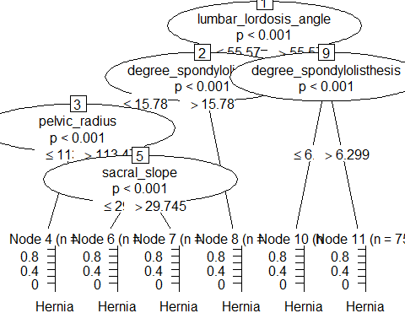

#predicting training and testing values and calculating accuracy  
train_pd_party <- predict(tree1, train)  
train_pd_party

## [1] Hernia Hernia Hernia Hernia   
## [5] Hernia Hernia Hernia Hernia   
## [9] Normal Hernia Hernia Hernia   
## [13] Hernia Hernia Normal Hernia   
## [17] Normal Hernia Hernia Hernia   
## [21] Hernia Hernia Hernia Hernia   
## [25] Hernia Hernia Hernia Hernia   
## [29] Normal Hernia Normal Normal   
## [33] Hernia Hernia Hernia Hernia   
## [37] Hernia Hernia Hernia Hernia   
## [41] Hernia Normal Spondylolisthesis Spondylolisthesis  
## [45] Spondylolisthesis Spondylolisthesis Spondylolisthesis Spondylolisthesis  
## [49] Spondylolisthesis Spondylolisthesis Spondylolisthesis Spondylolisthesis  
## [53] Spondylolisthesis Spondylolisthesis Spondylolisthesis Spondylolisthesis  
## [57] Spondylolisthesis Spondylolisthesis Spondylolisthesis Spondylolisthesis  
## [61] Spondylolisthesis Spondylolisthesis Spondylolisthesis Spondylolisthesis  
## [65] Spondylolisthesis Spondylolisthesis Spondylolisthesis Spondylolisthesis  
## [69] Spondylolisthesis Spondylolisthesis Spondylolisthesis Spondylolisthesis  
## [73] Spondylolisthesis Spondylolisthesis Spondylolisthesis Spondylolisthesis  
## [77] Spondylolisthesis Normal Spondylolisthesis Spondylolisthesis  
## [81] Spondylolisthesis Spondylolisthesis Spondylolisthesis Spondylolisthesis  
## [85] Spondylolisthesis Spondylolisthesis Spondylolisthesis Spondylolisthesis  
## [89] Spondylolisthesis Spondylolisthesis Spondylolisthesis Spondylolisthesis  
## [93] Spondylolisthesis Spondylolisthesis Spondylolisthesis Spondylolisthesis  
## [97] Spondylolisthesis Spondylolisthesis Spondylolisthesis Spondylolisthesis  
## [101] Spondylolisthesis Spondylolisthesis Spondylolisthesis Spondylolisthesis  
## [105] Spondylolisthesis Spondylolisthesis Spondylolisthesis Spondylolisthesis  
## [109] Spondylolisthesis Spondylolisthesis Spondylolisthesis Spondylolisthesis  
## [113] Spondylolisthesis Spondylolisthesis Spondylolisthesis Spondylolisthesis  
## [117] Spondylolisthesis Spondylolisthesis Spondylolisthesis Spondylolisthesis  
## [121] Spondylolisthesis Spondylolisthesis Spondylolisthesis Spondylolisthesis  
## [125] Spondylolisthesis Spondylolisthesis Spondylolisthesis Spondylolisthesis  
## [129] Spondylolisthesis Spondylolisthesis Spondylolisthesis Spondylolisthesis  
## [133] Spondylolisthesis Spondylolisthesis Spondylolisthesis Spondylolisthesis  
## [137] Spondylolisthesis Spondylolisthesis Spondylolisthesis Spondylolisthesis  
## [141] Spondylolisthesis Spondylolisthesis Spondylolisthesis Spondylolisthesis  
## [145] Spondylolisthesis Spondylolisthesis Spondylolisthesis Hernia   
## [149] Normal Normal Normal Normal   
## [153] Normal Normal Hernia Hernia   
## [157] Normal Spondylolisthesis Normal Normal   
## [161] Normal Hernia Normal Normal   
## [165] Hernia Normal Normal Normal   
## [169] Normal Normal Normal Normal   
## [173] Normal Normal Normal Normal   
## [177] Normal Spondylolisthesis Normal Spondylolisthesis  
## [181] Normal Normal Normal Hernia   
## [185] Hernia Normal Hernia Normal   
## [189] Normal Normal Hernia Normal   
## [193] Normal Normal Normal Normal   
## [197] Normal Normal Normal Normal   
## [201] Normal Normal Normal Normal   
## [205] Normal Hernia Normal Normal   
## [209] Spondylolisthesis Hernia Hernia Normal   
## [213] Normal Normal Normal Normal   
## [217] Hernia   
## Levels: Hernia Normal Spondylolisthesis

test_pd1_party <- predict(tree1,test)  
test_pd1_party

## [1] Hernia Hernia Normal Normal   
## [5] Normal Hernia Normal Hernia   
## [9] Hernia Hernia Hernia Normal   
## [13] Normal Hernia Hernia Normal   
## [17] Hernia Normal Normal Spondylolisthesis  
## [21] Spondylolisthesis Spondylolisthesis Spondylolisthesis Spondylolisthesis  
## [25] Spondylolisthesis Spondylolisthesis Spondylolisthesis Spondylolisthesis  
## [29] Spondylolisthesis Spondylolisthesis Spondylolisthesis Spondylolisthesis  
## [33] Spondylolisthesis Spondylolisthesis Spondylolisthesis Spondylolisthesis  
## [37] Spondylolisthesis Spondylolisthesis Spondylolisthesis Spondylolisthesis  
## [41] Spondylolisthesis Spondylolisthesis Spondylolisthesis Spondylolisthesis  
## [45] Spondylolisthesis Spondylolisthesis Spondylolisthesis Spondylolisthesis  
## [49] Spondylolisthesis Spondylolisthesis Spondylolisthesis Spondylolisthesis  
## [53] Spondylolisthesis Spondylolisthesis Spondylolisthesis Spondylolisthesis  
## [57] Spondylolisthesis Spondylolisthesis Spondylolisthesis Spondylolisthesis  
## [61] Spondylolisthesis Spondylolisthesis Spondylolisthesis Hernia   
## [65] Normal Normal Normal Normal   
## [69] Hernia Normal Hernia Normal   
## [73] Normal Normal Hernia Normal   
## [77] Normal Normal Normal Hernia   
## [81] Normal Normal Normal Normal   
## [85] Normal Normal Normal Normal   
## [89] Normal Normal Normal Normal   
## [93] Normal   
## Levels: Hernia Normal Spondylolisthesis

t1 <- table(Acutal = train$class, Predicted = train_pd_party)  
t1

## Predicted  
## Acutal Hernia Normal Spondylolisthesis  
## Hernia 35 7 0  
## Normal 13 53 4  
## Spondylolisthesis 0 1 104

train_accuracy_party = sum(diag(t1)/sum(t1)) *100  
train_accuracy_party

## [1] 88.47926

t1_tested <- table(Acutal = test$class, Predicted = test_pd1_party)  
t1_tested

## Predicted  
## Acutal Hernia Normal Spondylolisthesis  
## Hernia 10 8 0  
## Normal 5 25 0  
## Spondylolisthesis 0 1 44

test_accuracy_party = sum(diag(t1_tested)/sum(t1_tested)) *100  
test_accuracy_party

## [1] 84.94624

### using rpart package  
tree2 <- rpart(class~., data = train)  
tree2

## n= 217   
##   
## node), split, n, loss, yval, (yprob)  
## * denotes terminal node  
##   
## 1) root 217 112 Spondylolisthesis (0.19354839 0.32258065 0.48387097)   
## 2) degree_spondylolisthesis< 16.07889 113 46 Normal (0.37168142 0.59292035 0.03539823)   
## 4) sacral_slope< 28.13647 26 6 Hernia (0.76923077 0.23076923 0.00000000) *  
## 5) sacral_slope>=28.13647 87 26 Normal (0.25287356 0.70114943 0.04597701)   
## 10) pelvic_radius< 119.3285 36 19 Hernia (0.47222222 0.44444444 0.08333333)   
## 20) sacral_slope< 46.64911 27 10 Hernia (0.62962963 0.33333333 0.03703704)   
## 40) pelvic_radius< 113.6416 13 1 Hernia (0.92307692 0.07692308 0.00000000) *  
## 41) pelvic_radius>=113.6416 14 6 Normal (0.35714286 0.57142857 0.07142857) *  
## 21) sacral_slope>=46.64911 9 2 Normal (0.00000000 0.77777778 0.22222222) *  
## 11) pelvic_radius>=119.3285 51 6 Normal (0.09803922 0.88235294 0.01960784) *  
## 3) degree_spondylolisthesis>=16.07889 104 3 Spondylolisthesis (0.00000000 0.02884615 0.97115385) *

rpart.plot(tree2)

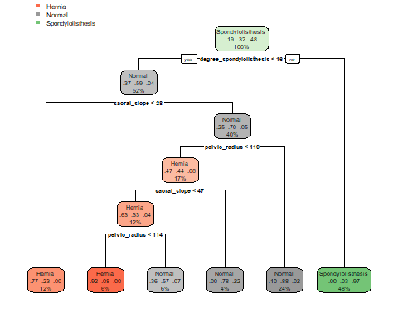

#pd_rpart <- predict(tree2, train, type="prob")  
#pd  
pd_rpart_train <- predict(tree2, train,type = "class")  
pd_rpart_train

## 1 3 5 6   
## Hernia Hernia Hernia Hernia   
## 10 12 13 14   
## Hernia Hernia Normal Hernia   
## 16 17 18 19   
## Normal Hernia Hernia Hernia   
## 20 21 22 23   
## Normal Normal Normal Hernia   
## 24 25 26 27   
## Normal Hernia Hernia Hernia   
## 28 29 30 32   
## Hernia Hernia Hernia Hernia   
## 34 35 37 39   
## Hernia Hernia Hernia Hernia   
## 40 41 43 45   
## Normal Hernia Normal Normal   
## 46 48 50 52   
## Hernia Hernia Hernia Hernia   
## 53 55 56 57   
## Hernia Hernia Hernia Hernia   
## 59 60 61 62   
## Hernia Normal Spondylolisthesis Spondylolisthesis   
## 63 64 65 66   
## Spondylolisthesis Spondylolisthesis Normal Spondylolisthesis   
## 67 68 70 71   
## Spondylolisthesis Spondylolisthesis Spondylolisthesis Spondylolisthesis   
## 72 74 77 81   
## Spondylolisthesis Spondylolisthesis Spondylolisthesis Spondylolisthesis   
## 82 84 85 86   
## Spondylolisthesis Spondylolisthesis Spondylolisthesis Spondylolisthesis   
## 87 89 90 91   
## Spondylolisthesis Spondylolisthesis Spondylolisthesis Spondylolisthesis   
## 92 93 95 96   
## Spondylolisthesis Spondylolisthesis Spondylolisthesis Spondylolisthesis   
## 97 98 99 100   
## Spondylolisthesis Spondylolisthesis Spondylolisthesis Spondylolisthesis   
## 101 102 103 104   
## Spondylolisthesis Spondylolisthesis Spondylolisthesis Spondylolisthesis   
## 105 106 109 110   
## Spondylolisthesis Normal Spondylolisthesis Spondylolisthesis   
## 111 112 115 116   
## Spondylolisthesis Spondylolisthesis Spondylolisthesis Spondylolisthesis   
## 117 118 119 120   
## Spondylolisthesis Spondylolisthesis Spondylolisthesis Spondylolisthesis   
## 121 122 123 124   
## Spondylolisthesis Spondylolisthesis Spondylolisthesis Spondylolisthesis   
## 127 129 130 131   
## Spondylolisthesis Spondylolisthesis Spondylolisthesis Spondylolisthesis   
## 132 133 135 139   
## Spondylolisthesis Spondylolisthesis Spondylolisthesis Spondylolisthesis   
## 140 142 144 146   
## Spondylolisthesis Spondylolisthesis Spondylolisthesis Spondylolisthesis   
## 147 149 150 154   
## Spondylolisthesis Spondylolisthesis Spondylolisthesis Spondylolisthesis   
## 158 159 160 161   
## Spondylolisthesis Spondylolisthesis Spondylolisthesis Spondylolisthesis   
## 162 164 165 166   
## Spondylolisthesis Spondylolisthesis Spondylolisthesis Spondylolisthesis   
## 167 168 170 171   
## Spondylolisthesis Normal Spondylolisthesis Spondylolisthesis   
## 172 173 174 177   
## Normal Spondylolisthesis Spondylolisthesis Spondylolisthesis   
## 178 179 181 183   
## Spondylolisthesis Spondylolisthesis Spondylolisthesis Spondylolisthesis   
## 184 186 188 190   
## Spondylolisthesis Spondylolisthesis Spondylolisthesis Spondylolisthesis   
## 191 192 193 195   
## Spondylolisthesis Spondylolisthesis Spondylolisthesis Spondylolisthesis   
## 197 198 199 201   
## Spondylolisthesis Spondylolisthesis Spondylolisthesis Spondylolisthesis   
## 202 203 205 206   
## Spondylolisthesis Spondylolisthesis Spondylolisthesis Spondylolisthesis   
## 208 209 210 211   
## Spondylolisthesis Spondylolisthesis Spondylolisthesis Hernia   
## 212 213 214 215   
## Normal Normal Normal Normal   
## 218 219 220 221   
## Normal Normal Hernia Hernia   
## 222 223 224 226   
## Normal Spondylolisthesis Normal Normal   
## 227 229 230 231   
## Normal Normal Normal Normal   
## 235 239 240 241   
## Normal Normal Normal Normal   
## 242 245 246 247   
## Normal Normal Normal Normal   
## 249 250 251 252   
## Normal Normal Normal Normal   
## 253 254 255 256   
## Normal Normal Normal Spondylolisthesis   
## 258 260 261 262   
## Normal Normal Normal Normal   
## 263 264 265 266   
## Normal Normal Normal Normal   
## 267 269 272 273   
## Normal Normal Hernia Normal   
## 275 276 277 278   
## Normal Normal Normal Normal   
## 279 280 283 284   
## Normal Normal Normal Normal   
## 286 287 288 289   
## Normal Normal Normal Normal   
## 290 291 292 293   
## Normal Hernia Normal Normal   
## 294 297 298 300   
## Spondylolisthesis Hernia Hernia Normal   
## 301 303 305 308   
## Normal Normal Normal Normal   
## 310   
## Normal   
## Levels: Hernia Normal Spondylolisthesis

pd_rpart_test <- predict(tree2,test, type = "class")  
pd_rpart_test

## 2 4 7 8   
## Normal Hernia Normal Normal   
## 9 11 15 31   
## Normal Hernia Normal Hernia   
## 33 36 38 42   
## Hernia Hernia Hernia Normal   
## 44 47 49 51   
## Normal Hernia Hernia Normal   
## 54 58 69 73   
## Hernia Normal Normal Spondylolisthesis   
## 75 76 78 79   
## Spondylolisthesis Spondylolisthesis Spondylolisthesis Spondylolisthesis   
## 80 83 88 94   
## Spondylolisthesis Spondylolisthesis Spondylolisthesis Spondylolisthesis   
## 107 108 113 114   
## Spondylolisthesis Spondylolisthesis Spondylolisthesis Spondylolisthesis   
## 125 126 128 134   
## Spondylolisthesis Spondylolisthesis Spondylolisthesis Spondylolisthesis   
## 136 137 138 141   
## Spondylolisthesis Spondylolisthesis Spondylolisthesis Spondylolisthesis   
## 143 145 148 151   
## Spondylolisthesis Spondylolisthesis Spondylolisthesis Spondylolisthesis   
## 152 153 155 156   
## Spondylolisthesis Spondylolisthesis Spondylolisthesis Spondylolisthesis   
## 157 163 169 175   
## Spondylolisthesis Spondylolisthesis Spondylolisthesis Spondylolisthesis   
## 176 180 182 185   
## Spondylolisthesis Spondylolisthesis Spondylolisthesis Spondylolisthesis   
## 187 189 194 196   
## Spondylolisthesis Spondylolisthesis Spondylolisthesis Spondylolisthesis   
## 200 204 207 216   
## Spondylolisthesis Spondylolisthesis Spondylolisthesis Hernia   
## 217 225 228 232   
## Normal Normal Normal Normal   
## 233 234 236 237   
## Normal Normal Hernia Normal   
## 238 243 244 248   
## Normal Normal Hernia Normal   
## 257 259 268 270   
## Normal Normal Normal Hernia   
## 271 274 281 282   
## Normal Normal Normal Normal   
## 285 295 296 299   
## Normal Normal Normal Normal   
## 302 304 306 307   
## Normal Normal Normal Normal   
## 309   
## Normal   
## Levels: Hernia Normal Spondylolisthesis

t_rpart_train <- table(Acutal = train$class, Predicted = pd_rpart_train)  
t_rpart_train

## Predicted  
## Acutal Hernia Normal Spondylolisthesis  
## Hernia 32 10 0  
## Normal 7 60 3  
## Spondylolisthesis 0 4 101

accuracy1_train = sum (diag(t_rpart_train)/sum(t_rpart_train)) * 100  
accuracy1_train

## [1] 88.94009

t_rpart_test <- table(Acutal = test$class, Predicted = pd_rpart_test)  
t_rpart_test

## Predicted  
## Acutal Hernia Normal Spondylolisthesis  
## Hernia 9 9 0  
## Normal 4 26 0  
## Spondylolisthesis 0 1 44

accuracy1_test = sum (diag(t_rpart_test)/sum(t_rpart_test)) * 100  
accuracy1_test

## [1] 84.94624

train_acc_array = c()  
test_acc_array = c()  
  
#For 10 fold cross validation  
for (i in 1:10)  
{  
 split <- sample.split(data_more$class, SplitRatio = 0.7)  
 train <- subset(data_more, split == TRUE)  
 test <- subset(data_more, split == FALSE)  
 tree1 <- ctree(class~., data = train)  
 train_pd_party <- predict(tree1, train)  
 test_pd1_party <- predict(tree1,test)  
 t1 <- table(Acutal = train$class, Predicted = train_pd_party)  
 train_acc_array[i] = sum(diag(t1)/sum(t1)) *100  
 t1_tested <- table(Acutal = test$class, Predicted = test_pd1_party)  
 test_acc_array[i] = sum(diag(t1_tested)/sum(t1_tested)) *100  
}  
  
x <- c(1:10)  
plot(test_acc_array~x,t="l",ylim=c(72,90))  
lines(train_acc_array,t='l',col="blue")

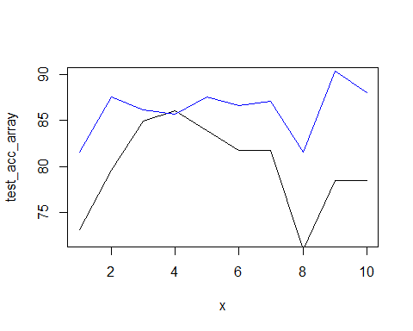

# using random forest for better accuracy and importance  
# Creating random trees  
  
random_forest_classifier <- randomForest(x = train[-7],  
 y=train$class,  
 ntree=500)  
  
# Predicting training data and testing data  
random_forest_classifier

##   
## Call:  
## randomForest(x = train[-7], y = train$class, ntree = 500)   
## Type of random forest: classification  
## Number of trees: 500  
## No. of variables tried at each split: 2  
##   
## OOB estimate of error rate: 12.44%  
## Confusion matrix:  
## Hernia Normal Spondylolisthesis class.error  
## Hernia 29 12 1 0.30952381  
## Normal 11 57 2 0.18571429  
## Spondylolisthesis 0 1 104 0.00952381

train_pred_RF <- predict(random_forest_classifier,train[-7])  
test_pred_RF <- predict(random_forest_classifier,test[-7])  
  
# Finding accuracy of training data adn testing data  
table_RF_train <- table(Acutal = train$class, Predicted = train_pred_RF)  
table_RF_train

## Predicted  
## Acutal Hernia Normal Spondylolisthesis  
## Hernia 42 0 0  
## Normal 0 70 0  
## Spondylolisthesis 0 0 105

train_accuracy_RF = sum(diag(table_RF_train)/sum(table_RF_train)) *100  
train_accuracy_RF

## [1] 100

table_RF_test <- table(Acutal = test$class, Predicted = test_pred_RF)  
table_RF_test

## Predicted  
## Acutal Hernia Normal Spondylolisthesis  
## Hernia 11 6 1  
## Normal 6 21 3  
## Spondylolisthesis 0 1 44

test_accuracy_RF = sum(diag(table_RF_test)/sum(table_RF_test)) *100  
test_accuracy_RF

## [1] 81.72043

# Plotting the error of random trees and importance of features  
plot(random_forest_classifier)

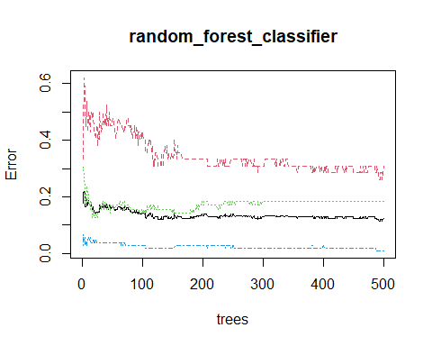

importance(random_forest_classifier)

## MeanDecreaseGini  
## pelvic_incidence 15.09326  
## pelvic_tilt 13.43869  
## lumbar_lordosis_angle 18.03142  
## sacral_slope 15.98425  
## pelvic_radius 15.76036  
## degree_spondylolisthesis 56.38590

# 3) Using KNN  
  
data <- read.csv("column_3C_weka.csv")  
data[,7] <- as.factor(data[,7])  
head(data)

features = data[-7]  
response <- data[7]  
response

## class  
## 1 Hernia  
## 2 Hernia  
## 3 Hernia  
## 4 Hernia  
## 5 Hernia  
## 6 Hernia  
## 7 Hernia  
## 8 Hernia  
## 9 Hernia  
.

.

.

.  
## 300 Normal  
## 301 Normal  
## 302 Normal  
## 303 Normal  
## 304 Normal  
## 305 Normal  
## 306 Normal  
## 307 Normal  
## 308 Normal  
## 309 Normal  
## 310 Normal

summary(features)

## pelvic_incidence pelvic_tilt lumbar_lordosis_angle sacral_slope   
## Min. : 26.15 Min. :-6.555 Min. : 14.00 Min. : 13.37   
## 1st Qu.: 46.43 1st Qu.:10.667 1st Qu.: 37.00 1st Qu.: 33.35   
## Median : 58.69 Median :16.358 Median : 49.56 Median : 42.40   
## Mean : 60.50 Mean :17.543 Mean : 51.93 Mean : 42.95   
## 3rd Qu.: 72.88 3rd Qu.:22.120 3rd Qu.: 63.00 3rd Qu.: 52.70   
## Max. :129.83 Max. :49.432 Max. :125.74 Max. :121.43   
## pelvic_radius degree_spondylolisthesis  
## Min. : 70.08 Min. :-11.058   
## 1st Qu.:110.71 1st Qu.: 1.604   
## Median :118.27 Median : 11.768   
## Mean :117.92 Mean : 26.297   
## 3rd Qu.:125.47 3rd Qu.: 41.287   
## Max. :163.07 Max. :418.543

features_norm = apply(features,2,minmax)  
data_new = cbind(features_norm,"class"=response)  
data_new

## pelvic_incidence pelvic_tilt lumbar_lordosis_angle sacral_slope  
## 1 0.35568788 0.51989984 0.22917997 0.250857300  
## 2 0.12450104 0.29678310 0.09857833 0.144629352  
## 3 0.41166648 0.51393229 0.32299466 0.307660537  
## 4 0.41615104 0.55741388 0.27125999 0.289435840  
## 5 0.22727187 0.28947930 0.12812869 0.247022051  
## 6 0.13600932 0.36574426 0.09955891 0.119943054  
## 7 0.26315004 0.40043867 0.20731555 0.223959571  
## 8 0.18535588 0.30918995 0.13458053 0.196591648  
## 9 0.17015073 0.35881131 0.25675856 0.156293676  
.

.

.

.  
## 302 0.60631987 0.58283243 0.49239381 0.458733615  
## 303 0.27440891 0.50090230 0.13746097 0.182712658  
## 304 0.07941640 0.15392252 0.16458231 0.175386116  
## 305 0.18254641 0.33689897 0.27369361 0.179540027  
## 306 0.20982214 0.36029264 0.19688142 0.193590933  
## 307 0.26800913 0.48719410 0.13621093 0.183674226  
## 308 0.34043781 0.52244298 0.28789745 0.234907261  
## 309 0.18425678 0.27235174 0.24684569 0.214622788  
## 310 0.07420202 0.20770855 0.20261992 0.142516594

## pelvic_radius degree_spondylolisthesis class  
## 1 0.30746116 0.0251483868 Hernia  
## 2 0.47664891 0.0363649708 Hernia  
## 3 0.38609692 0.0175229033 Hernia  
## 4 0.34182648 0.0518380744 Hernia  
## 5 0.40957929 0.0441727737 Hernia  
## 6 0.64787924 0.0309329409 Hernia  
## 7 0.54291624 0.0396803523 Hernia  
## 8 0.50745533 0.0008899132 Hernia  
.

.

.

.

.

.  
## 302 0.44520037 0.0398501788 Normal  
## 303 0.51899713 0.0223163018 Normal  
## 304 0.62607361 0.0179065189 Normal  
## 305 0.83679263 0.0049265899 Normal  
## 306 0.50938024 0.0158583874 Normal  
## 307 0.47622326 0.0247605611 Normal  
## 308 0.59779618 0.0194373246 Normal  
## 309 0.52117504 0.0262404463 Normal  
## 310 0.57924032 0.0252767637 Normal

accuracy <- c()  
  
split <- sample.split(data_new$class, SplitRatio = 0.7)  
train <- subset(data_new, split == TRUE)  
test <- subset(data_new, split == FALSE)  
  
predict = knn(train[,-7],test[,-7],train[,7],k=4)  
table1 = table(Actual = test[,7],predicted = predict)  
table1

## predicted  
## Actual Hernia Normal Spondylolisthesis  
## Hernia 9 8 1  
## Normal 6 22 2  
## Spondylolisthesis 5 5 35

accuracy1 = sum (diag(table1)/sum(table1))  
accuracy1

## [1] 0.7096774

for (i in 1:100)  
{  
 predict = knn(train[,-7],test[,-7],train[,7],k=i)  
 table1 = table(actual = test[,7],predicted = predict)  
 accuracy1 = sum (diag(table1)/sum(table1))  
 accuracy[i]=accuracy1*100  
}  
  
plot(accuracy, t="l")

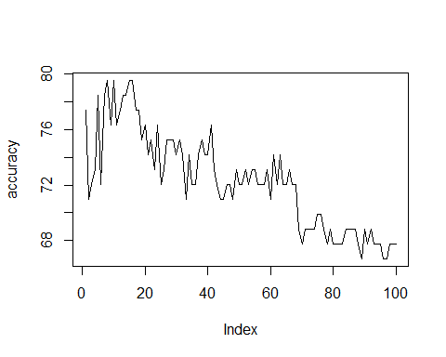

plot(accuracy[1:30],t="l")

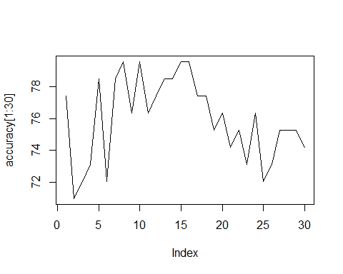

# 4) using SVM  
  
data <- read.csv("column_3C_weka.csv")  
kernellist <- c("linear","radial","polynomial",  
 "sigmoid")  
data[,7] <- as.factor(data[,7])  
#using different kernels to see which one gives best model  
accuracy_kernel <- c()  
for( i in 1:4)  
{  
 model <- svm(class~.,  
 data = data,kernel = kernellist[i])  
 summary(model)  
 pred <- predict(model,data=data)  
 t <- table(actual = data$class, Predicted = pred)  
 accuracy_kernel[i] = sum(diag(t))/sum(t) *100  
   
}  
  
  
accuracy_kernel

## [1] 87.74194 86.12903 82.58065 82.90323

accuracy_cost <- c()  
  
# Checking what is the best cost  
# For different kernels using different values  
  
gp <- c(10^seq(0,10))  
gp

## [1] 1e+00 1e+01 1e+02 1e+03 1e+04 1e+05 1e+06 1e+07 1e+08 1e+09 1e+10

gp_length <- c(0:10)  
gp_length

## [1] 0 1 2 3 4 5 6 7 8 9 10

j=1  
for (k in 1:4)   
{  
 for( i in gp)  
 {  
 model <- svm(class~.,  
 data = data,kernel = kernellist[k],cost = i)  
 pred <- predict(model,data=data)  
 t <- table(actual = data$class, Predicted = pred)  
 accuracy_cost[j] = sum(diag(t))/sum(t) *100  
 j <- j+1  
 #plot(model,data,Petal.Length~Petal.Width)  
 }  
   
 plot(gp_length,accuracy_cost[(j-11):(j-1)], t="l",  
 xlab="powers of 10",ylab="accuracy",main=kernellist[k])  
   
}

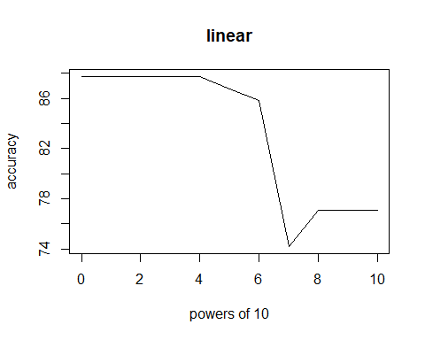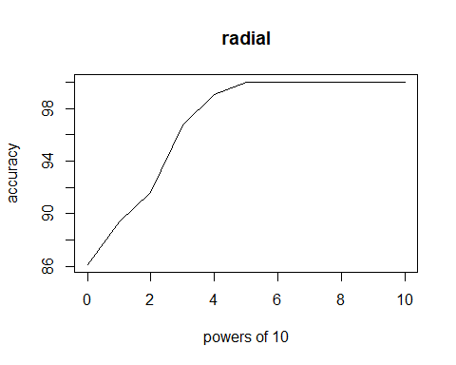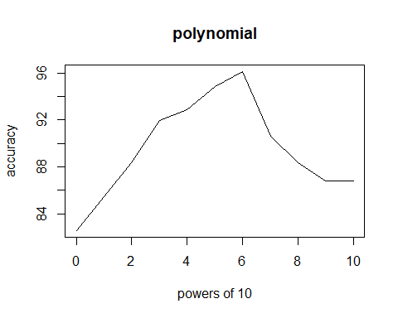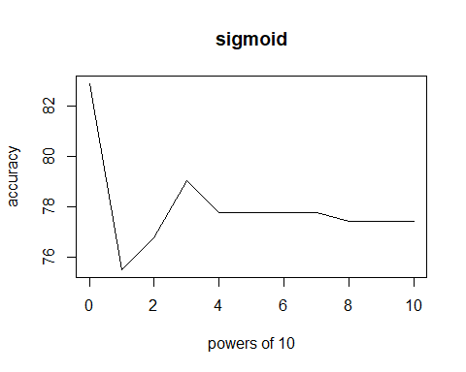

length(accuracy_cost)

## [1] 44

accuracy_cost

## [1] 87.74194 87.74194 87.74194 87.74194 87.74194 86.77419 85.80645  
## [8] 74.19355 77.09677 77.09677 77.09677 86.12903 89.35484 91.61290  
## [15] 96.77419 99.03226 100.00000 100.00000 100.00000 100.00000 100.00000  
## [22] 100.00000 82.58065 85.48387 88.38710 91.93548 92.90323 94.83871  
## [29] 96.12903 90.64516 88.38710 86.77419 86.77419 82.90323 75.48387  
## [36] 76.77419 79.03226 77.74194 77.74194 77.74194 77.74194 77.41935  
## [43] 77.41935 77.41935